Parking Efficiency Integration

CSUSB Parking

Team Members:

Sally Phang

James Huang

James Small

Leigh-Anna Griswould

**SSD For Vehicle Entering Parking Lot**

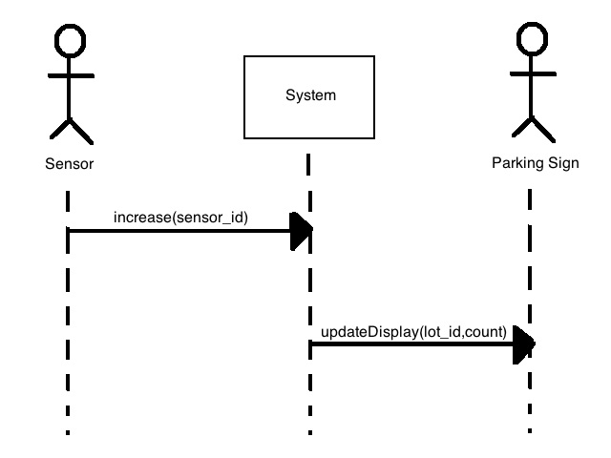

**Interaction Diagram For Vehicle Entering Parking Lot**

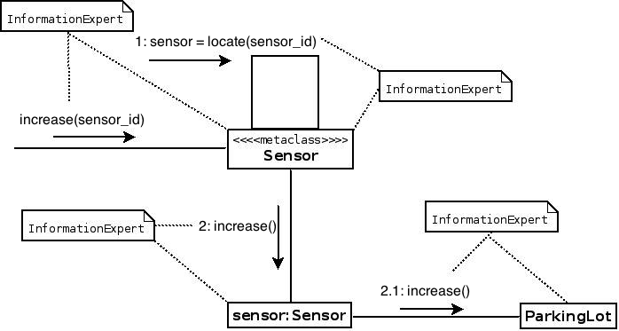

**Interaction Diagram For Vehicle Exiting Parking Lot**

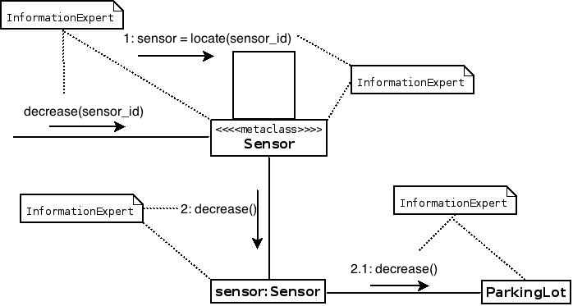

**Interaction Diagram For Updating Count on Parking Lot**

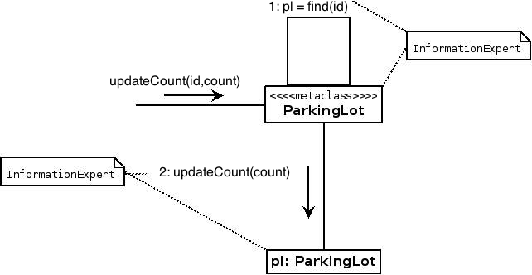

**Class Diagram**

